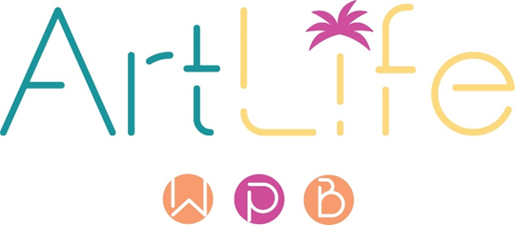

CALLING ALL PALM BEACH COUNTY ARTISTS!

THE COMMONS: Endless Summer
5 Artists 5 Spaces: A Local Artists Public Art Initiative

PROJECT OPPORTUNITY
The City of West Palm Beach (“City”) requests qualifications from professional Palm Beach County artists to create temporary public artworks. The Commons: 5 Artists 5 Spaces offers opportunities for local artists to take their art practice from their studio and create in the public realm. The ArtLife Committee will select five (5) local artists to create new site-specific and theme-based temporary public artworks.

APPLICATION DEADLINE: August 5, 2024, at 7pm EST

CURATORIAL VISION
Five mulitdiscplinary artists will be commissioned to create temporary artworks that engage the public by incorporating “endless summer” as the central theme. Against the backdrop of the tropics, and amongst a vibrant community on the rise, how does West Palm’s endless summer influence you as an artist? With the community in mind, show us through a unique artwork what an endless summer means to you and how you envision this theme in the public realm.

PROJECT GOALS
- The artwork reflects the theme of the project, Endless Summer.
- The proposed artwork is of high artistic quality.
- The artwork makes a positive visual impact.
- The work is an original, one-of-a-kind, new work.

TOTAL PROJECT BUDGET: $125,0000
Five artists to receive up to $25,000 each. Each award will include a not to exceed $5,000 artist fee with the remaining balance for design, materials, build, installation, insurance, etc.
*Invoice and documentation will be required for the project.

LOCATIONS
Jose Marti Park
City Hall Plaza
Mandel Library

The committee will approve the final location for each proposed work of art. City staff will work closely with the selected artists to ensure that the selected sites meet the goals of the project, are feasible, and do not pose a health or public safety hazard. Concepts must be sensitive to racial, cultural, religious, and political opinions.

ELIGIBILITY
Open to professional artists over 18 years of age who reside in Palm Beach County. Proof of residency will be required, and residency will be verified. Artist must be willing to meet all contractual obligations.

APPLICATION
Step 1:
All applicants must submit a current professional resume (not to exceed two pages) that confirms them as professional artists, as defined in the City’s Code of Ordinances, and that includes the applicants’ residential address in Palm Beach County. The top line of the applicant’s resume must include the applicant’s full name and physical mailing address. P.O. Boxes will not be accepted and will be disqualified.

The city is NOT seeking proposals at this application stage.

Submit a 90-second video about you and your art practice. Be creative. Applicants with videos exceeding the 90-second limit will automatically be disqualified. Applicants with proposals will be disqualified. Submit videos to https://www.publicartist.org/.

Deadline to submit videos, resumes, and documentation of residency: August 5, 2024.
Submit to https://www.publicartist.org.

Applications submitted via email will not be considered. Applicants must apply through https://www.publicartist.org.

Step 2: SELECTION PROCESS
Once the application period is closed, the ArtLife Committee will review all qualifying video submissions and select 10 artists to develop conceptual proposals. The selected 10 artists will present to the ArtLife Committee for consideration to be selected for The Commons: 5 Artists 5 Spaces project. Compensation will be $500 per artist. The five (5) selected artists will go under a formal agreement with the city.

The ArtLife Committee will consider the following criteria when reviewing proposals:
- Reflection of theme
- Cultural impact
- Quality of artwork
- Appropriateness to site
- Diversity in art medium
- Artist qualifications

ANTICIPATED TIMELINE
June 2024: Call published.
August 2024: Deadline to submit videos.
September 2024: Committee reviews applicants & selects 10 artists for proposal.
October 2024: Deadline for proposals.
November 2024: The Committee reviews proposals and selects 5 artists for commission.
January 2025 Artworks completed and installed.

For more information, please email scwelter@wpb.org subject line, The Commons: Endless Summer.

DISCLAIMER
Proposers should rely exclusively on their own site investigations for the development of proposals, concepts, and means and methods of installation/fabrication. This Call is being provided by the City without any warranty or representation, expressed or implied, as to its content, accuracy, or completeness and no proposer or other party shall have recourse to the City if any information herein contained shall be inaccurate or incomplete.
This Call is made subject to correction of errors, omissions, or withdrawal without notice.
No warranty or representation is made by the City that any proposal conforming to these requirements will be selected for consideration, negotiation, or approval. The City is under no obligation to award a commission for artwork based on the proposals submitted. The City may withdraw or cancel this Call at any time without any liability or obligation on the part of the City and ArtLife. In its sole discretion, the City, through its ArtLife Committee may determine the qualifications of any artist submitting proposals. The City and Proposer will be bound only when a proposal, as it may be modified, is approved, and accepted by the City and the applicable contract is approved by the City Commission and executed and delivered by the artist and the City.

THE COMMONS: Endless Summer

SITE LOCATIONS

CITY HALL PLAZA
401 Clematis St, West Palm Beach, FL 33401
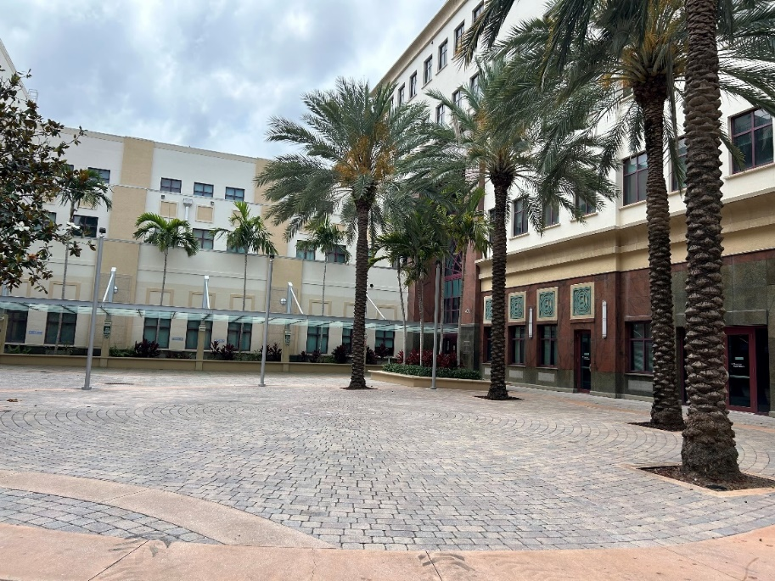
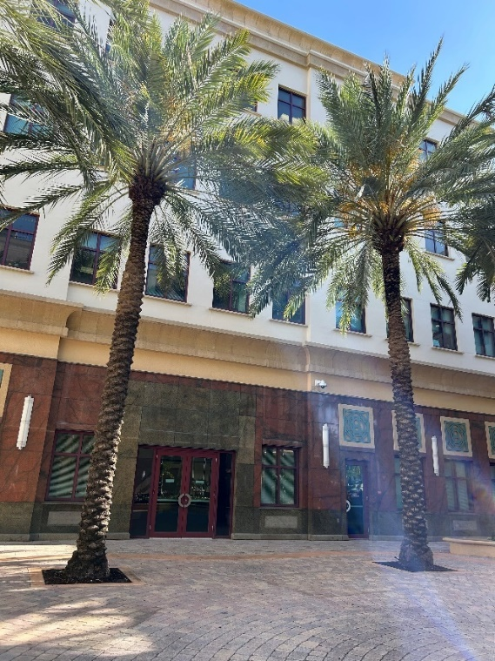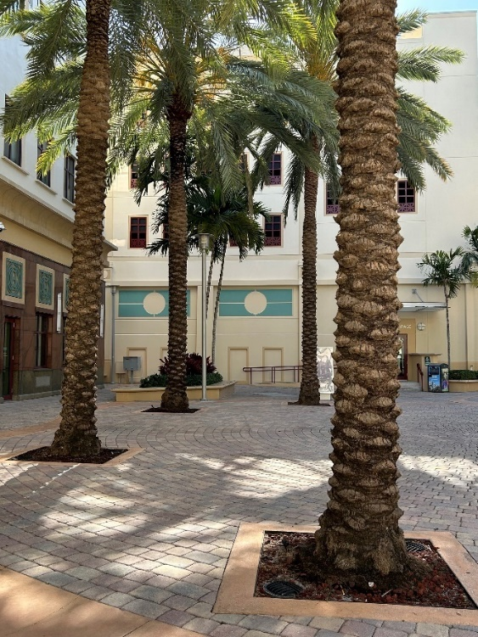

MANDEL PUBLIC LIBRARY (1ST FLOOR)
411 Clematis St, West Palm Beach, FL 33401
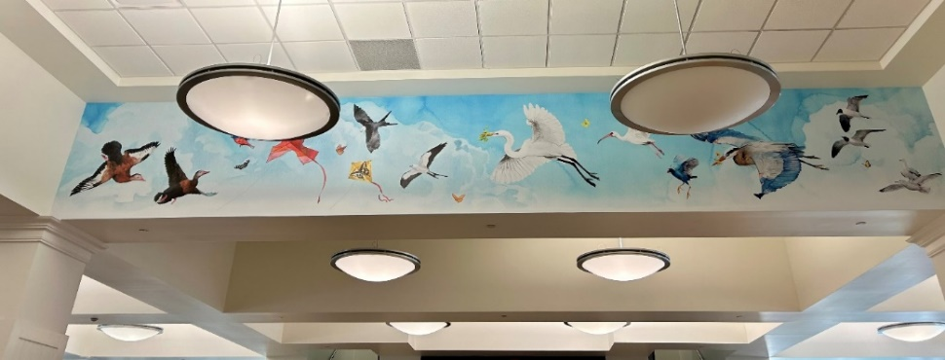
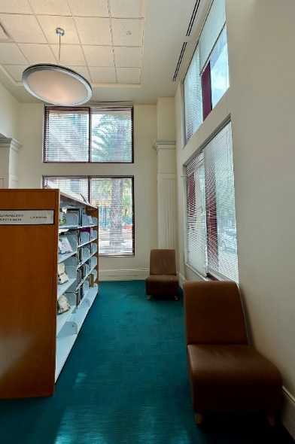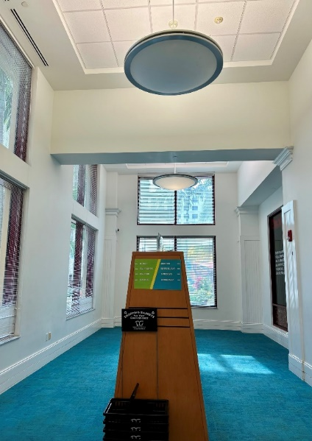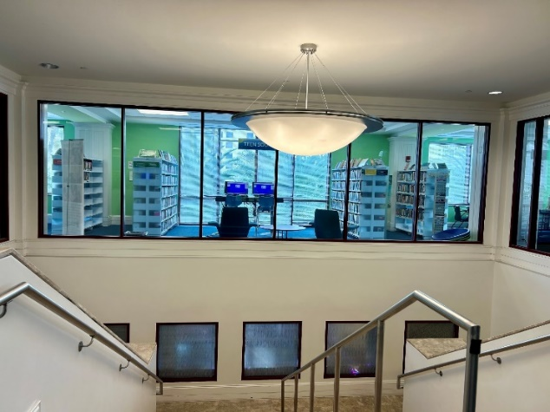

MANDEL PUBLIC LIBRARY (4th FLOOR)
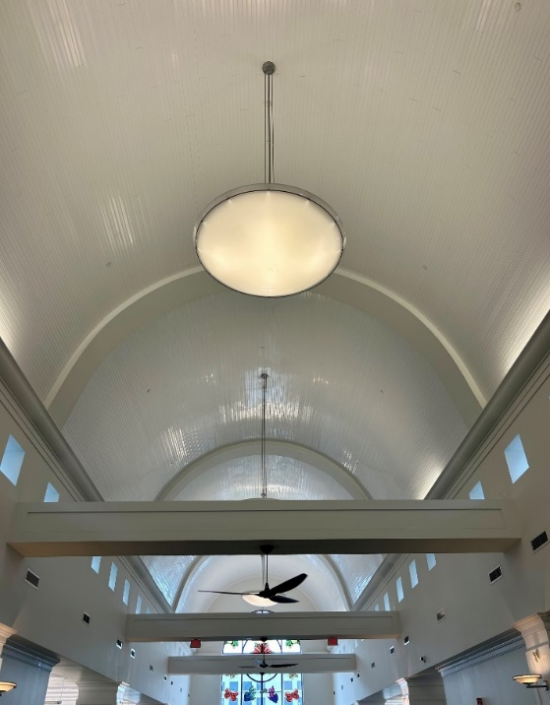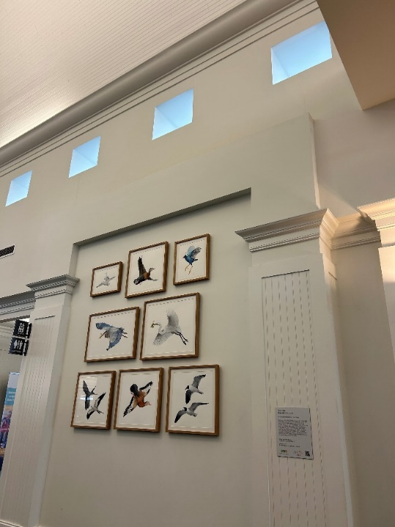
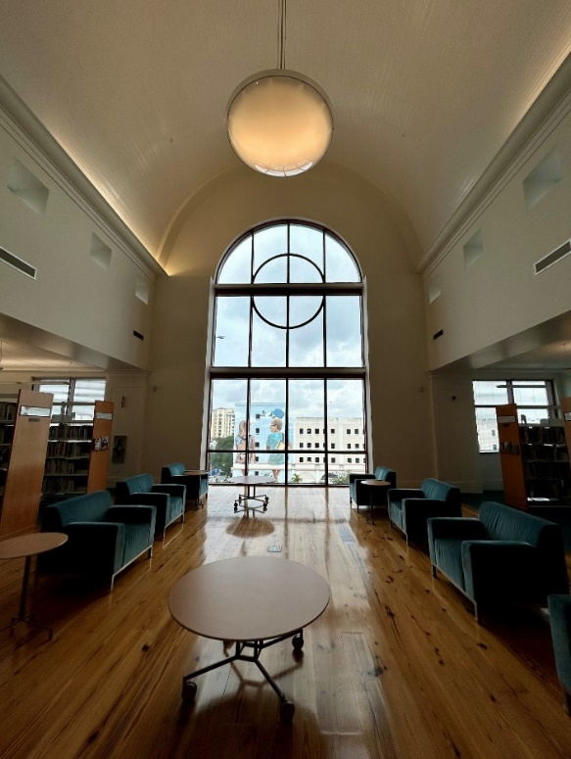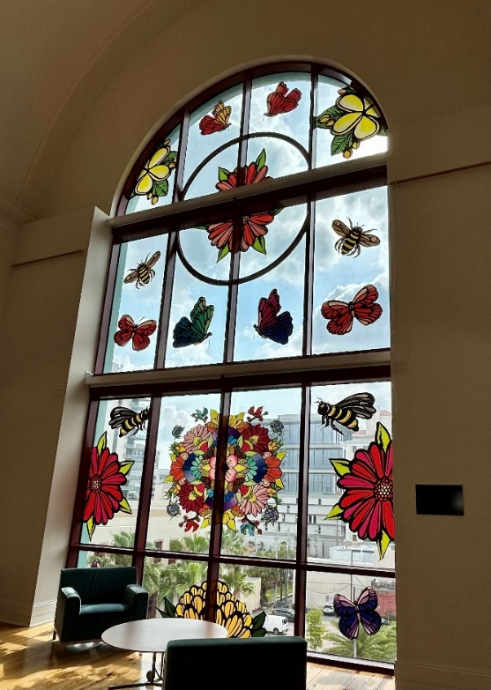
JOSE MARTI PARK
351 N Flagler Dr, West Palm Beach, FL 33401
